**EDA Report**

**Data Summary:**

* 1000 rows from 2 days (March 16 & 17, 2022)
* Features: coin, symbol, price, volume, market cap, % changes
* 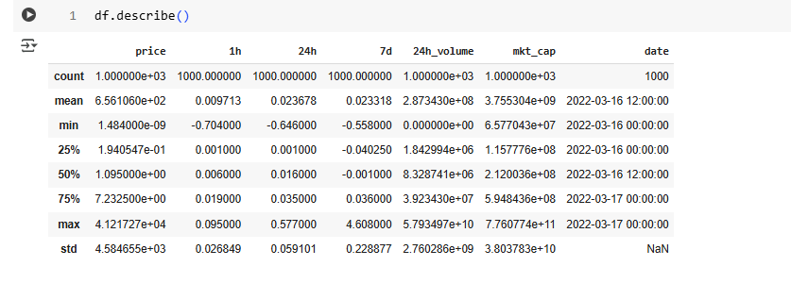

**Missing Values:**

* Minor missing values in % change columns filled using median imputation

**Distribution Observations:**

* price, volume, and market_cap are heavily right-skewed
* Most coins are priced under $10, few like BTC/ETH are outliers

**Correlation Analysis:**

* Strong correlation between log_volume and log_mkt_cap
* 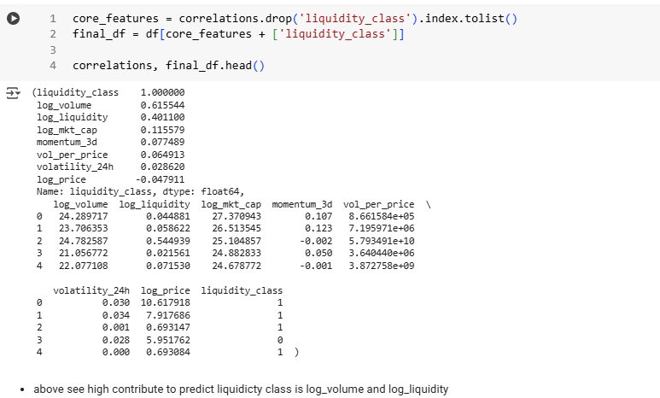Liquidity ratio moderately correlated with both

**Visual Insights:**

* Coins with high volume often have high market cap
* Volatile coins tend to have lower liquidity
* Scatter plots and pairplots confirmed feature relevance and separability

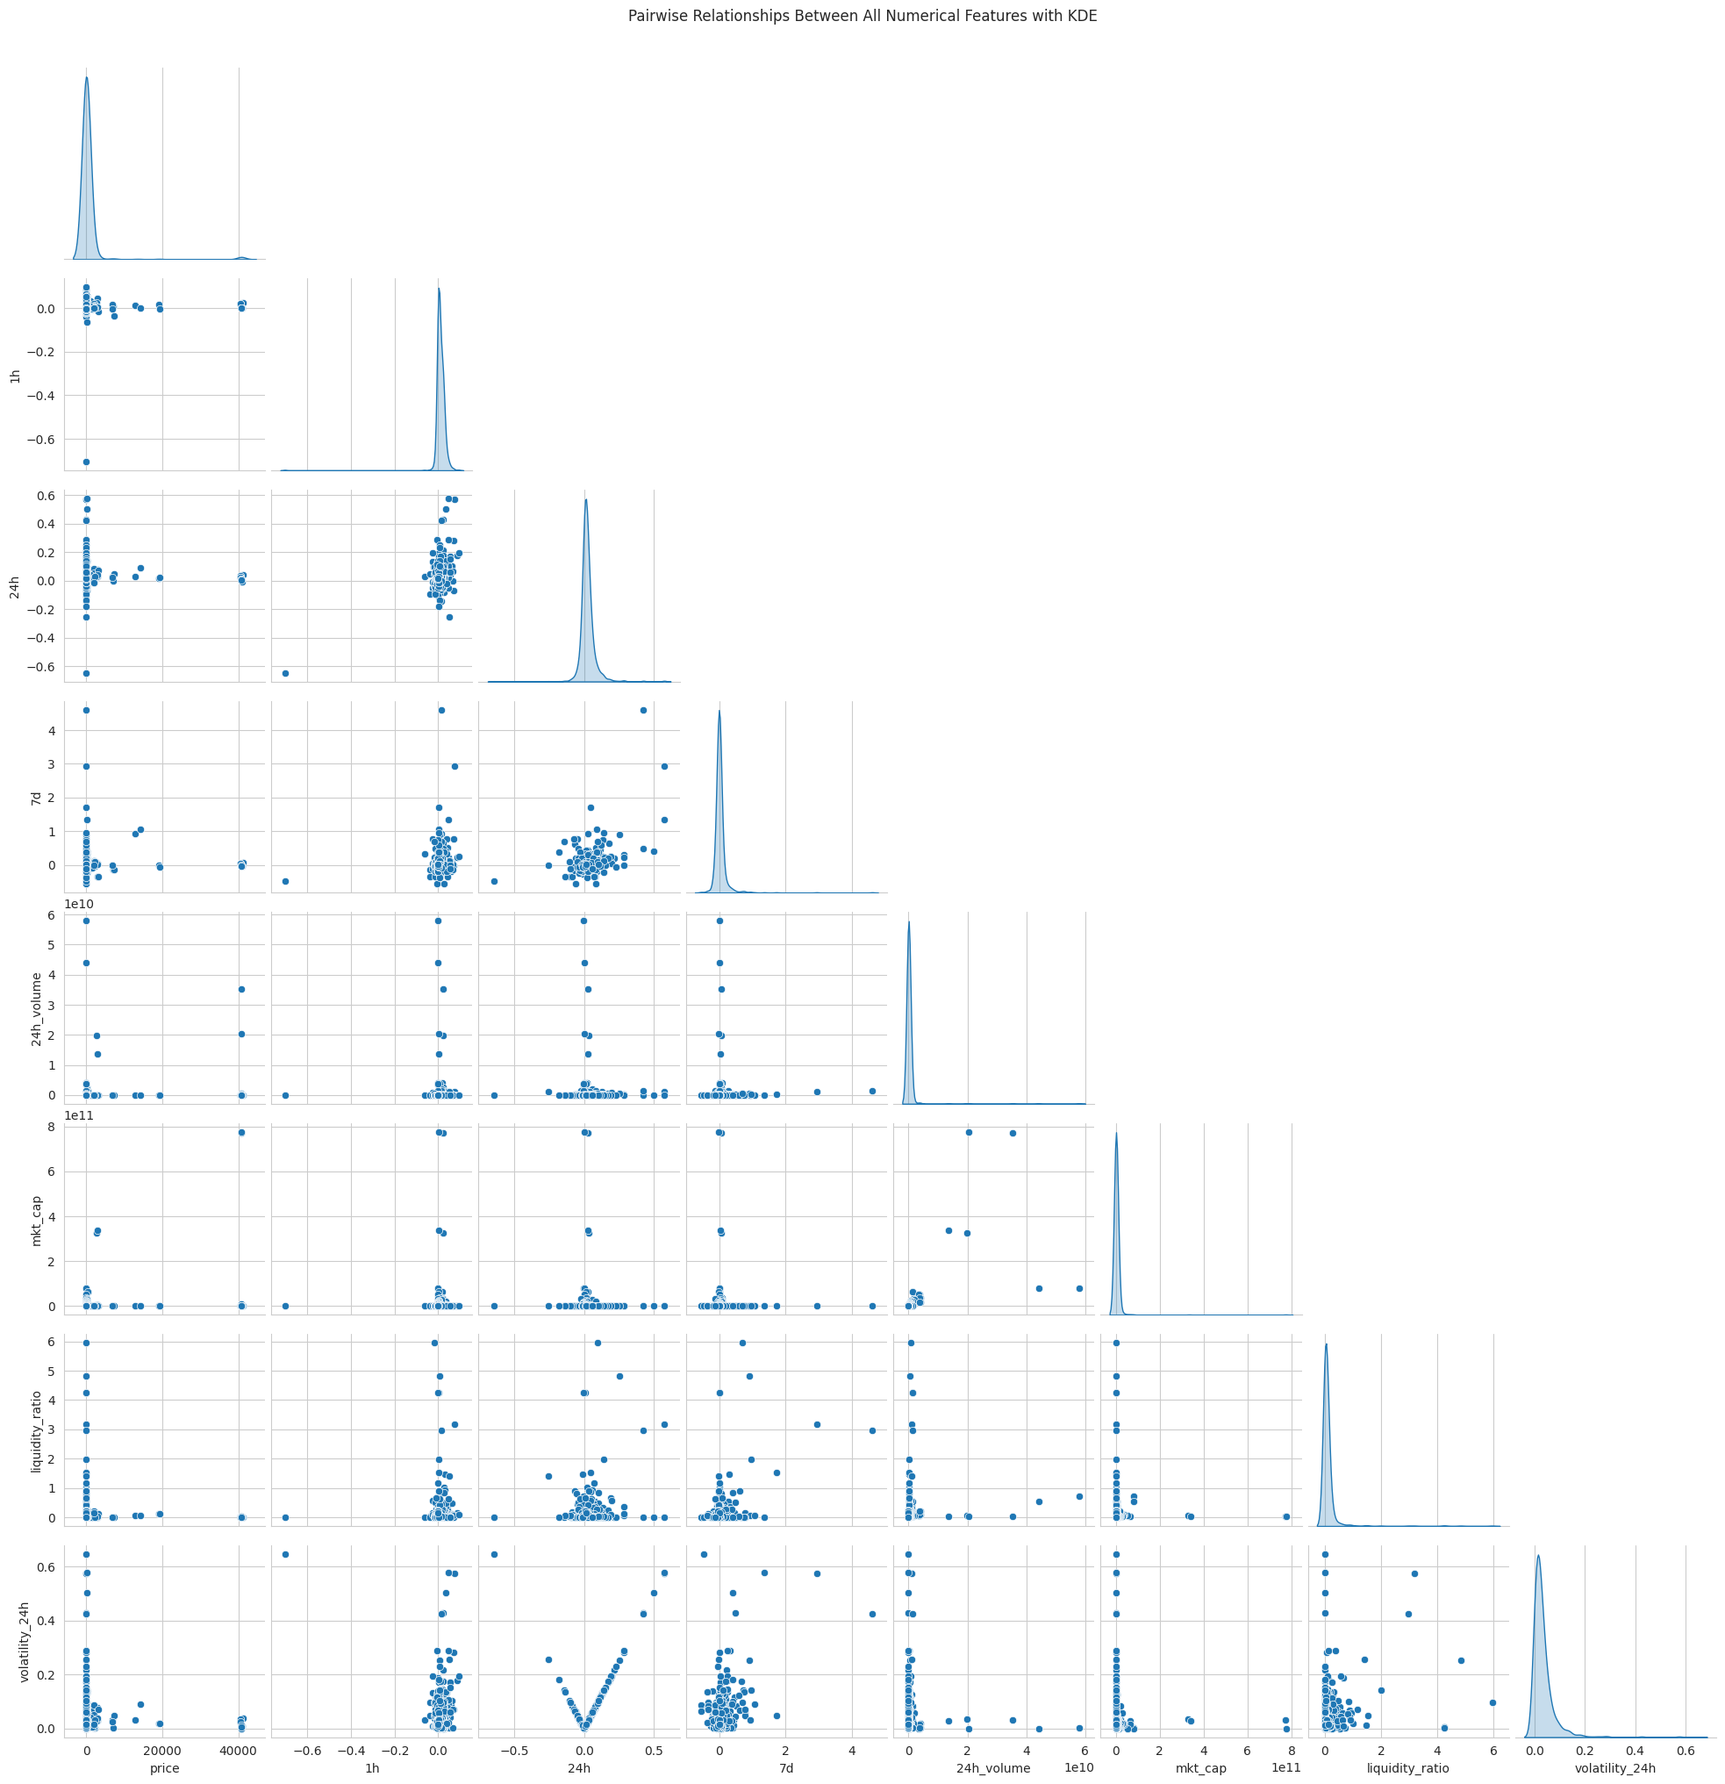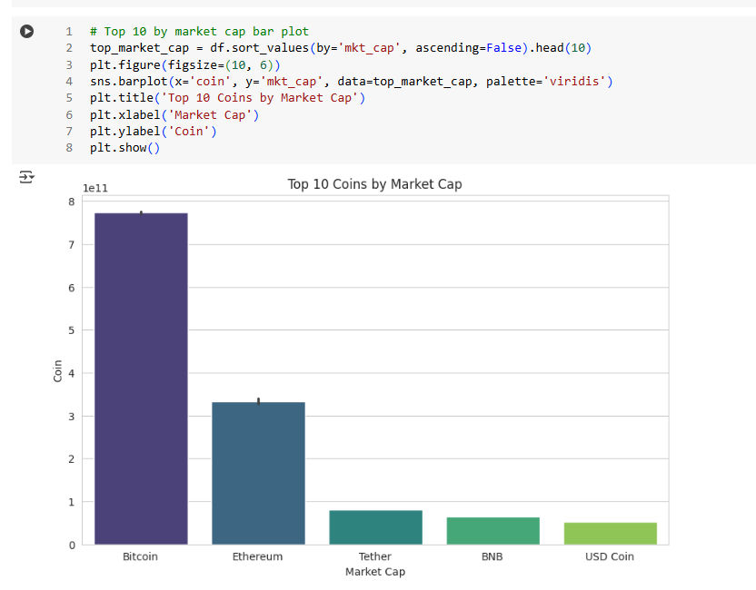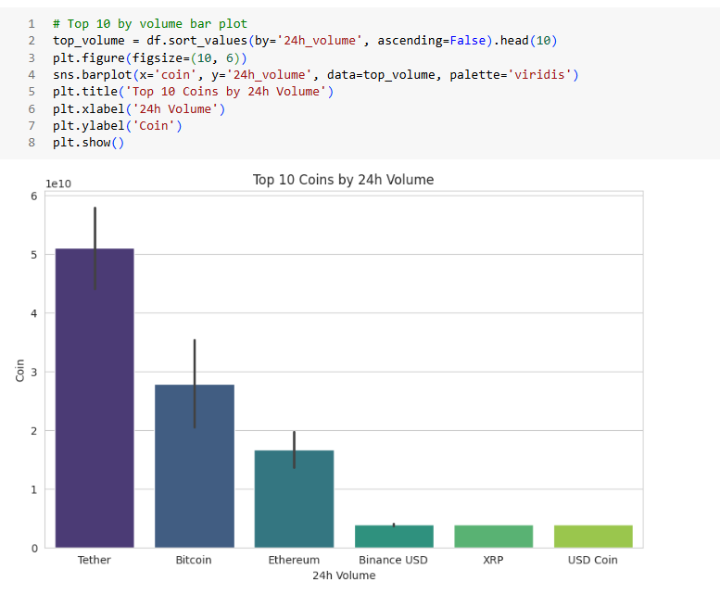



**Feature Selection:**

* Features like log_volume, log_liquidity, and momentum_3d were chosen based on both correlation and visual patterns
  + Further eda report preferred Jupiter notebook